The HF X-ray Generator consists of an inverter and oil-filled tank which houses the high voltage transformer and tube. It has been designed and developed for OEM application using transmission tube for neonatal care. The high frequency output allows for lower kV per exposure, shorter exposure and superior imaging.
HF MONOBLOCK FOR NEONATAL CARE
40W/ 1kW

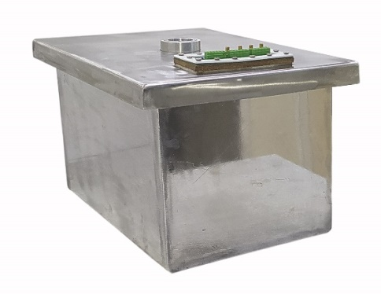
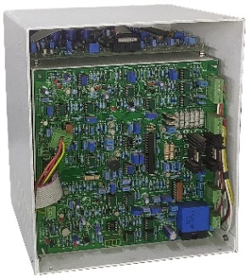
Features:
- Compact & light weight
- Reduction in dose
- Superior Imaging
- Tablet / Keyboard /touch-Screen Control
- Easy Serviceability

Technical Specifications
PARAMETER | SPECIFICATION
Rating | 40W | 1kW
Input Voltage | 90 - 264VAC, single phase 47-63Hz (1kW)
Protections | Over voltage, over current, over temperature, arc
Interface | RS232 & USB
TUBE VOLTAGE PERFORMANCE
Output Voltage | -40kV to -80 kV | -40kV to -100 kV
kV Rise | To -80kV in less than 10 msec | To -100kV in less than 5 msec
kV Fall time | From -80kV to -25kV in less than 6 msec | From -100kV to -25kV in less than 6 msec
kV Repeatability | ± 10%
kV Stability | ± .5%
kV Ripple | ≤ 1% rms
Line Regulation | ±0.1% over a range of line voltage from 90 to 264V
Load regulation | ±0.1% over a range of emission current from 0.01mA to 0.5mA | ±0.1% over a range of emission current from 1.0mA to 10.0mA
kV Accuracy | ± 2% of target
BIAS VOLTAGE PERFORMANCE
Bias Voltage Operational Range | -300V to 800 V (-300V~0, 0~800V)
V rise | 0 to 800V in less than 1.0 msec
V fall time | From 800V to 0V in less than 0.02 msec
V repeatability | ± 10%
V stability | ± 2%
V Ripple | ≤ 1% rms
V Accuracy | ± 2% of target
- OEM Customization Available

For any queries or customization requests contact us at info@ionics.co.in
For product line information visit us at www.ionics.co.in

